

**Semester VI (CS, SE) Section (A) (Spring 2022) Course Instructor(s): Riaz Ali Soomro**

**CSC-325: Web Engineering - Lab**

Lab 04: Introduction to JavaScript

# Objective(s):

1. Learn Basics of JavaScript

**Lab Task(s):**

**Exercises**

TASK1

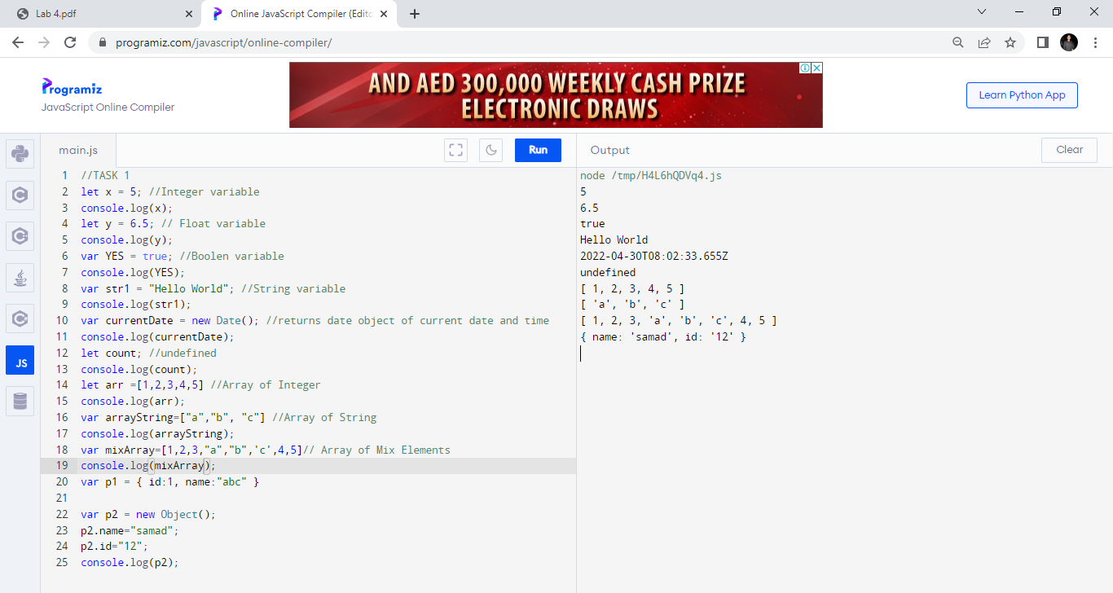

TASK2

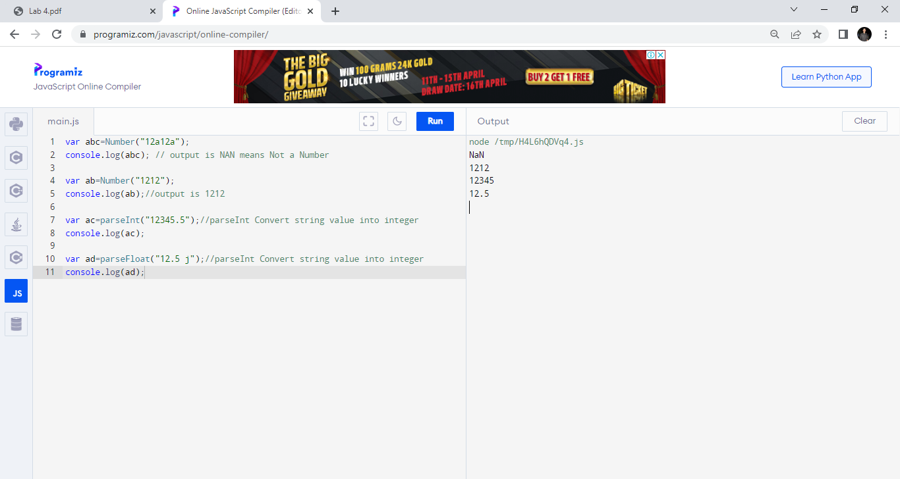

TASK 3

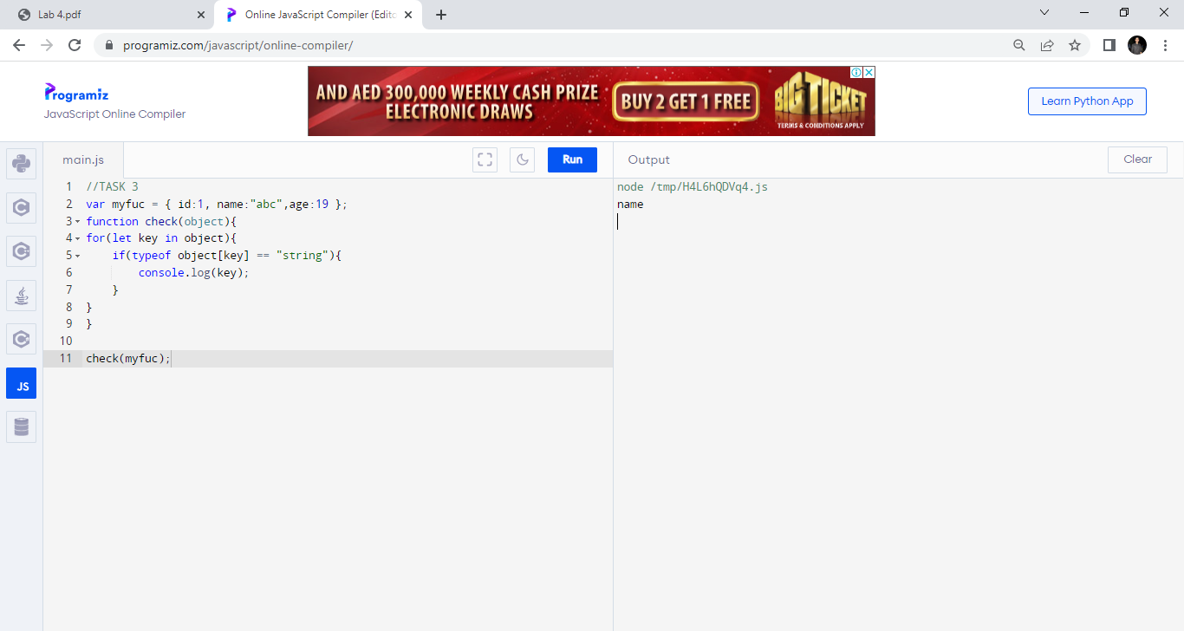

TASK 4

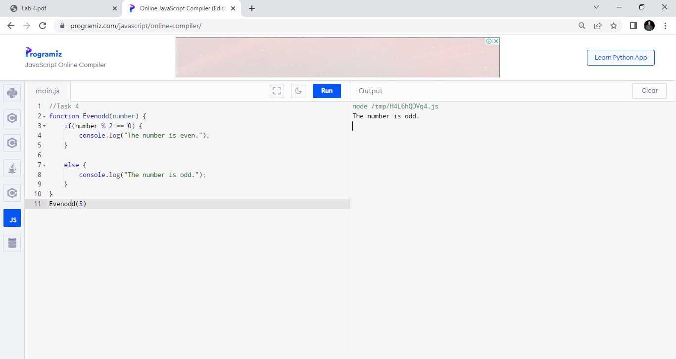

TASK 5

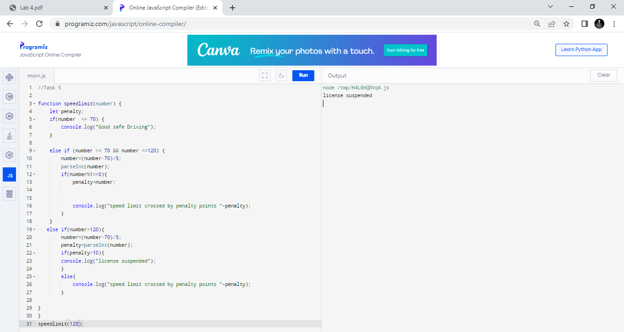

TASK 6

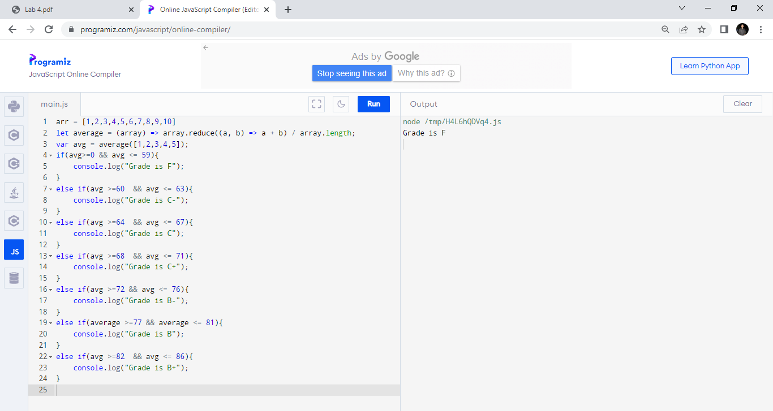

TASK 7

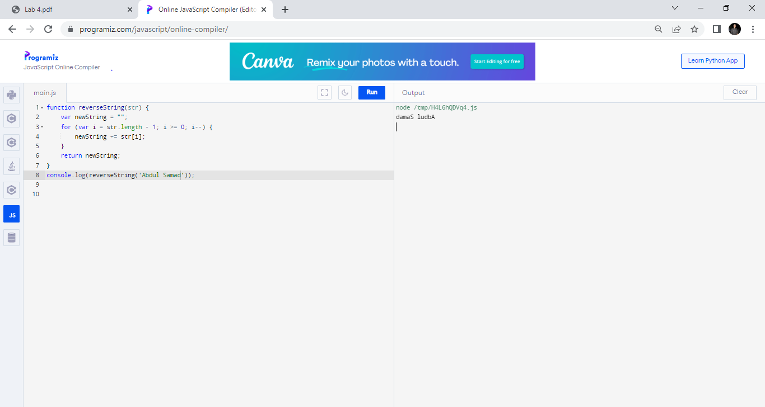

TASK 8

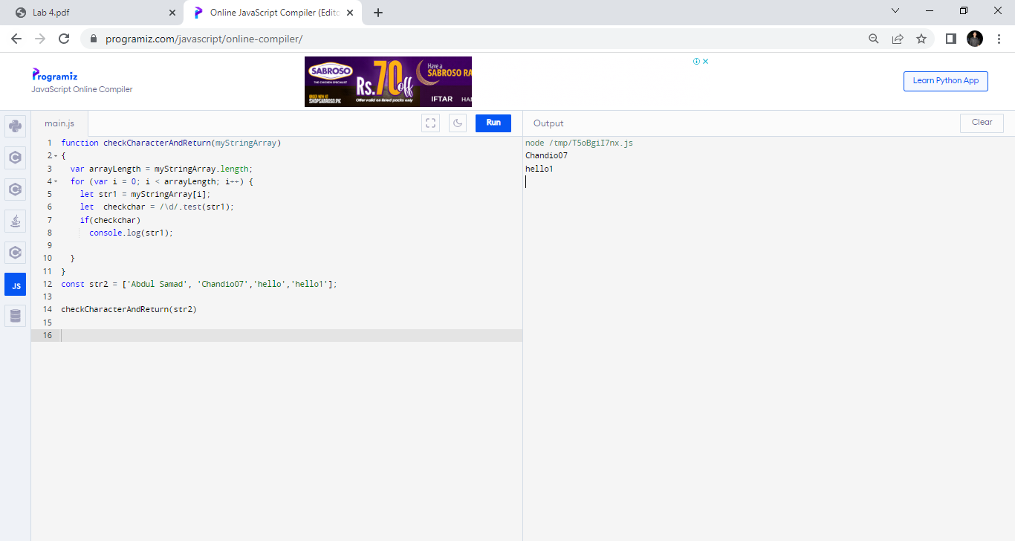

TASK 9

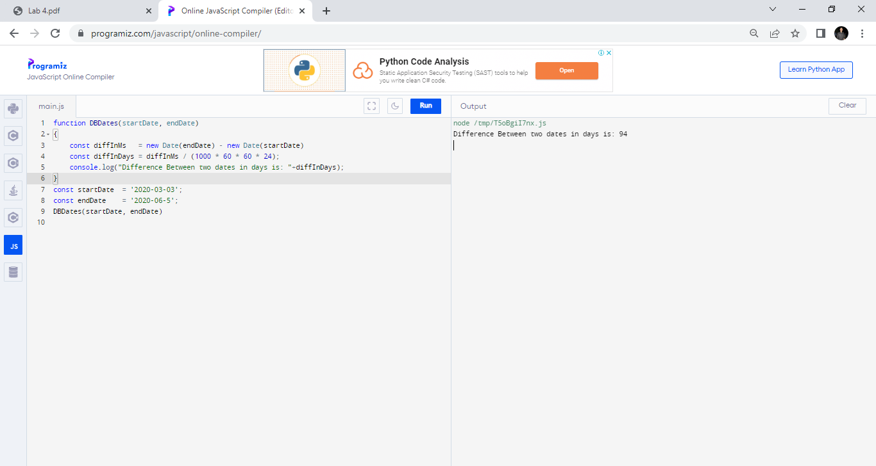

TASK 10

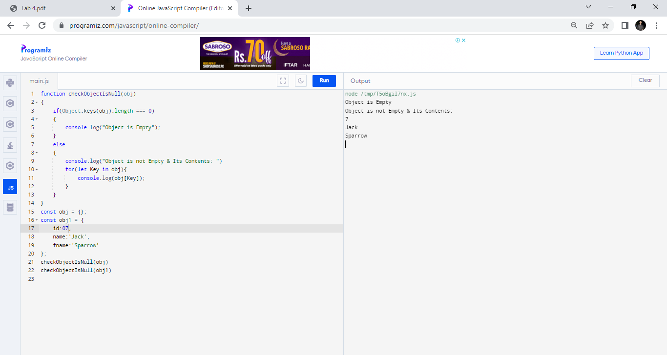

TASK 11

